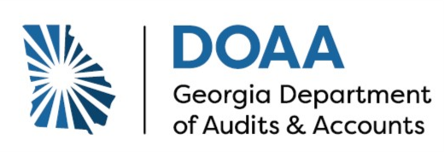

**DATE:** August 7, 2025

**TO:** County Tax Commissioners / City Clerks

**FROM:** Sara McLeod, Deputy Director – Financial Audits

**SUBJECT:** Property Tax Confirmation Updates

To provide clearer guidance and improved support to our Local Education Authorities (School Districts), we have implemented the following updates to the Property Tax Confirmation form originally revised for Fiscal Year 2022. These updates have been carried forward to the Fiscal Year 2023, 2024, and 2025 forms. Any new changes for the current fiscal year are noted below.

1. **Submission Format:** We are requesting that you complete the Property Tax Confirmation form using the provided Excel file and return it to us electronically via email. To streamline this process, a manual signature is no longer required.
2. **Updates to the “comm” Tab (First Page):**
   1. A drop-down menu is now available to allow selection of the School District by typing and choosing from a list. (See below for an example for Bacon County Board of Education.)

* 1. A new row has been included to enter a secondary due date, if applicable. If there is only one due date, you may leave this field blank.



* 1. A new question regarding Tax Abatements has been included. If the School District does not have any, select “No” from the drop-down menu, and you may skip the “Tax Abatement” tab.



* 1. A drop-down menu has been added to select either “Tax Commissioner of” or “City Clerk of”.

1. **General Improvements Across All Tabs:** Minor updates have been made throughout the form to improve formatting consistency and ensure that all totals reconcile accurately with submitted check details.
2. **Enhanced Usability Features:**
   * *Shaded fields* now indicate required inputs.
   * *Automated calculations* have been added to foot and cross-foot amounts.
   * A *verification check* has been included—“TRUE” confirms totals match, while “FALSE” indicates a discrepancy that must be reviewed before submission.
   * Certain editing features have been locked to protect the accuracy and integrity of the form.
3. **Fiscal Year 2025 Update:** In this year’s version, totals from the “all taxes” tabs are now automatically carried over to the “comm” tab using Excel formulas. This allows for quicker and easier certification of complete and accurate information.

1. **Additional Reporting Requirement:** Please indicate the month in which taxes were transmitted for payments made between July 1, 2025, and August 31, 2025. Also, specify the tax types included in the current Delinquent Balance.

Important Note: House Bill 581, known as the *Save the Homes Act*, went into effect on January 1, 2025. This law sets a floating homestead exemption that limits year-over-year increases in assessed value for homestead residential properties to the rate of inflation (based on the Consumer Price Index), with 2024 assessed value as the base. For School Districts that did not opt out by March 1, 2025, the exemption applies beginning in tax year 2025, and assessment caps are enforced starting in 2026.

Auditors may also request documentation that demonstrates how the exemption was applied and how it affected the digest and related tax collections. It is important to retain clear records of base-year values, exemption calculations, and any adjustments for compliance and audit support.

If you have any questions or require further clarification, please don’t hesitate to reach out. We appreciate your continued cooperation and support.